**DATE: ${day}-${month}-${year}**

To,

Principal Officer,

Mercantile Marine Office,

Govt. Office Building No.-1,

Agrabad, Chattogram.

Re : Application for issue NOC of **MV. ${vessel}**

Dear Sir,

Please be informed you that **MV. ${vessel}** arrived at Chattogram port on ${arrived} and she will be completed her cargo operation approximate at 1100-1300 hrs day after tomorrow.

Meantime we submitted NOC to your good office today around 1000 hrs LT and for your kind information, Due to misinformanation of C&F agent we could not comply the rules of Government to engage lighter vessel from Mercantile Marine Office, Which have been even instructed by CPA. As such we would like to assure you that in future we will advise consignee/C&F Agent/releted parties to take lighter vessel from MMO & comply with all Government rules and regulations.

Therefore you are requested to Issue NOC as well as sail the vessel from Chittagrom port to avoid huge demurrage and we are agree to co-operate your good office to apply the Government instruction of engage lighter vessel from MMO and oblige thereby.

Thanking You

Yours Faithfully

MULTIPORT SHIPPING LTD

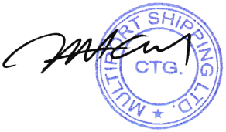

AS AGENT